FinMate AI – Problem Definition and Solution

The problem
Most households have no single, accurate record of where their money goes, so overspending is noticed only at month end, when it is too late to fix.
- Spending is scattered. Money leaves through UPI, cards and cash, and through several family members. Paper receipts fade or get lost, and small cash spends are rarely written down.
- Manual tracking is tedious. Typing every expense into an app takes effort, so most people stop after a few weeks. Older or less tech-savvy family members find forms hard to use.
- No family-level view. Expense apps are built for one person. A parent cannot see the household's combined spending or set one shared budget for the family.
- Reports without advice. Apps show pie charts but do not say what to change. People need specific, local suggestions, such as "take the metro for your daily commute instead of a cab".
- No one watches continuously. Budgets are checked only when the user remembers to open the app, so warnings come late or not at all.
Problem statement: Design and build an agentic AI system that captures expenses from receipt images, voice notes and forms, tracks them against personal and family budgets, and acts on its own to warn users and suggest cheaper alternatives before they overspend.

How FinMate AI solves it
FinMate AI replaces a passive expense tracker with a team of AI agents that record expenses, watch budgets and give advice without being asked.
Problem | FinMate AI's answer | Module
Spending is scattered, receipts get lost | Every expense is captured in one cloud record, with the original receipt file stored | Receipt management
Manual tracking is tedious | Snap a photo, speak a voice note ("spent 450 on cab"), or fill a short form; the agent extracts amount, date, merchant and category | Receipt management
No family-level view | A family group with admin and member roles; the admin sees every member's spend and the household total | Family mode
Budgets are checked too late | Monthly limits per category for a person or the family; alerts at 80% and 100% of a limit | Budgeting mode
Reports without advice | The Insights Agent finds weak habits and suggests cheaper options, e.g. metro instead of cab, cooking instead of ordering in | Smart insights

What makes it agentic, not just an app
- Autonomous: agents act on events (a new receipt, a budget crossing 80%) without the user asking.
- Goal-driven planning: the Orchestrator Agent breaks a request into steps and assigns each one.
- Tool use: agents call OCR, speech-to-text, database queries and an LLM as needed.
- Shared memory: every agent reads past expenses and advice, so suggestions are based on the user's own history.
- Human in the loop: the user confirms extracted receipt fields and approves budget changes.
Out of scope: bank or UPI account linking, making payments, investment advice and native mobile apps.

Architecture
FinMate AI uses a supervisor pattern: one Orchestrator Agent receives every request and delegates work to four specialist agents, which share one cloud memory.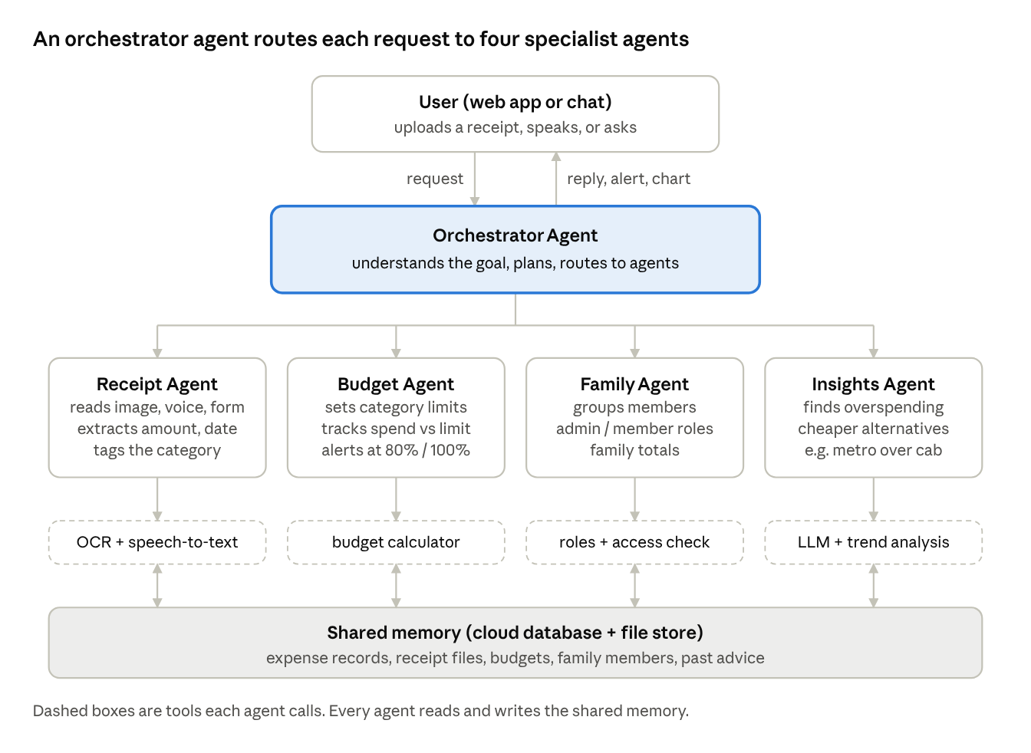
FinMate AI multi-agent architecture · 1 orchestrator, 4 specialist agents, shared memory
The user talks only to the Orchestrator. Specialist agents call their own tools, save results to shared memory, and report back, so the Orchestrator can combine their work into one reply.

Agents
Each agent owns one job, decides which tools to use, and can act on its own when its trigger fires.
Agent | Goal | Tools it calls | Acts on its own when
Orchestrator Agent | Understand the request, plan steps, combine the answers | The four specialist agents | Any message, upload or scheduled check arrives
Receipt Agent | Turn an image, voice note or form into a clean expense record | OCR, speech-to-text, LLM field extractor | A receipt is uploaded; asks the user to confirm unclear fields
Budget Agent | Keep each person and the family within category limits | Budget calculator, database queries | Spend crosses 80% or 100% of a limit
Family Agent | Manage the family group and who can see what | Auth and role checks | A member joins, or a family view is requested
Insights Agent | Find weak spending habits and suggest cheaper options | LLM reasoning, trend analysis on past spend | The Budget Agent flags overspending, or the weekly review runs

Example run: a cab receipt pushes Transport over budget
- The user uploads an Uber receipt photo. The Orchestrator sends it to the Receipt Agent.
- The Receipt Agent runs OCR and extracts ₹450, today's date, merchant Uber and category Transport. The user confirms, and the record is saved.
- The Budget Agent sees Transport is now at 112% of the monthly limit and raises an alert.
- The Orchestrator passes the alert to the Insights Agent, which finds 18 cab rides on the same route in the last 30 days.
- The Insights Agent replies: "Taking the metro on this daily route could save most of your cab spend. Want me to lower next month's cab budget?"
- If the user belongs to a family group, the Family Agent adds the alert to the admin's family view.

